**Quantum Information and Computing**

**- Assignement 5 Report -**

Andrea Turci, November 2024

**1. Introduction**

This report focuses on the time-dependent quantum harmonic oscillator, where the Hamiltonian features a potential minimum that shifts linearly with time. The system's dynamics were studied using both real-time and imaginary-time evolutions, and a numerical approach based on the split-step Fourier method and Trotter-Suzuki decomposition was used to handle the complexities introduced by the time dependence of the potential. The primary objective was to analyze the behavior of the wavefunction and the average position of the particle under different conditions, with particular attention to how varying the total simulation time $T$ influences the results. The investigation also included the computation of residuals between the particle's average position and its linear trend, followed by a Fourier analysis to extract the frequency of oscillations in real time. By comparing real-time and imaginary-time results, I highlight the differences in the particle’s response to the dynamic potential, underlying the expected behaviour of real time evolution and imaginary time evolution.

**2. Theoretical Framework**

The time-dependent quantum harmonic oscillator involves solving the Schrödinger equation for a system with a Hamiltonian that evolves explicitly with time:

$$\hat{H}\left(t\right)=\hat{\frac{p^{2}}{2m}}+\frac{mω^{2}}{2}{\left(\hat{x}-x_{0}\left(t\right)\right)}^{2}$$

where the potential's minimum shifts linearly over time, $x_{0}\left(t\right)=t/T$. This explicit time dependence adds complexity to the problem, requiring numerical methods to solve the time-dependent Schrödinger equation:

$$iℏ\frac{∂Ψ(x,t)}{∂t}=\hat{H}\left(t\right)Ψ(x,t)$$

**2.1 The Split-Step Method and Trotter-Suzuki Decomposition**

Considering the numerical approach, a powerful tool to handle this problem is the split-step Fourier method, which leverages the Trotter-Suzuki decomposition to approximate the time evolution operator.

For a small enough time step $Δt$, the time evolution operator (or propagator) is:

$$\hat{U}(Δt) = e^{-\frac{i}{ℏ} \hat{H}(t)Δt}$$

The state evolution for a time $t=NΔt$ is obtained by successive application of the above operator, then:

$$Ψ\left(x,t\right)=\hat{U}{\left(Δt\right)}^{N}Ψ\left(x,0\right)$$

The Hamiltonian can be separated into a kinetic term $\hat{T}=\frac{{\hat{p}}^{2}}{2m}$ and a potential term $\hat{V}\left(t\right)=\frac{mω^{2}}{2}{\left(\hat{x}-x_{0}\left(t\right)\right)}^{2}$:

$$\hat{H}(t)=\hat{T}+\hat{V}(t)$$

Since $\hat{T}$ and $\hat{V}\left(t\right)$ do not commute, directly evaluating $e^{-\frac{i}{ℏ} \hat{H}(t)Δt}$ is impractical. The Trotter-Suzuki decomposition provides an approximation:

$$\hat{U}\left(Δt\right)≈e^{-\frac{i}{2ℏ} \hat{V}\left(t\right)Δt}e^{-\frac{i}{ℏ} \hat{T}Δt}e^{-\frac{i}{2ℏ} \hat{V}\left(t\right)Δt}+O\left(Δt^{3}\right)$$

The Trotter-Suzuki decomposition works because, for sufficiently small $Δt$, the coupling between the kinetic and potential terms becomes negligible to higher-order terms $O\left(Δt^{3}\right)$.

Physically, this separation reflects the intuitive idea that over an infinitesimally small time interval, the kinetic and potential energy contributions act almost independently. Indeed, considering the potential energy contribution, the term $e^{-\frac{i}{2ℏ} \hat{V}\left(t\right)Δt}$ modifies the wavefunction by introducing position-dependent phase shifts. This accounts for the force the particle experiences due to the time-dependent potential at a given position $x$. During this step, the kinetic effects (like spreading) are momentarily ignored. Then, the kinetic term $e^{-\frac{i}{ℏ} \hat{T}Δt}$, evaluated in momentum space, modifies the wavefunction by spreading or oscillating its components, reflecting the motion due to the particle's momentum. In this step, the potential energy contributions are frozen. Finally, by symmetrically applying half the potential operator before and after the kinetic operator, we minimize the error introduced by neglecting the commutator $\left[\hat{T},\hat{V}\left(t\right)\right]$. Also, the symmetric approach cancels the dominant second-order error term.

The Trotter-Suzuki decomposition is derived from the Baker-Campbell-Hausdorff (BCH) formula, since the two operators $\hat{T}$ and $\hat{V}\left(t\right)$ do not commute. This formula asserts this relation for two non-commutative operators $\hat{A}$ and $\hat{B}$:

$$e^{ \hat{A}+\hat{B}}=e^{ \hat{A}}e^{ \hat{B}}e^{-\frac{1}{2}\left[\hat{A},\hat{B}\right]}+O\left(Δt^{3}\right),$$

where in this case $\hat{A}=-\frac{i}{ℏ}\hat{T}Δt$ and $\hat{B}=-\frac{i}{ℏ}\hat{V}(t)Δt$.

Additionally, the Fourier transform plays a central role in the split-step method by enabling efficient computation of the kinetic term. The kinetic energy operator $\hat{T}$ is diagonal in momentum space:

$$\hat{T} \tilde{Ψ}\left(p\right)=\frac{p^{2}}{2m}\tilde{Ψ}\left(p\right),$$

but not in position space. So, to apply $\hat{T}$, the wavefunction is transformed to momentum space:

$$\tilde{Ψ}\left(p\right)=F \left[\tilde{Ψ}\left(x\right)\right]=\int{e^{-\frac{ipx}{ℏ}} Ψ\left(x\right)dx}$$

After applying the kinetic term, the wavefunction is transformed back to position space using the inverse Fourier transform $F^{-1}$. As previously said, in position space the kinetic operator involves second derivatives, making it computationally expensive to apply. Instead, in momentum space, it becomes diagonal, simplifying the computation to a pointwise multiplication:

$${\tilde{Ψ}}^{'}(p)=e^{-\frac{i}{ℏ}\frac{p^{2}}{2m}Δt}\tilde{Ψ}\left(p\right)$$

Efficient algorithms like the Fast Fourier Transform (FFT) enable rapid computation of the Fourier transform.

In this way, using the Trotter-Suzuki decomposition and the Fourier Transform operator, the final time evolution operator becomes:

$$\hat{U}\left(Δt\right)≃e^{-\frac{i}{2ℏ} \hat{V}\left(t\right)Δt}{ F}^{-1} e^{-\frac{i}{ℏ} \hat{T}Δt} F e^{-\frac{i}{2ℏ} \hat{V}\left(t\right)Δt}$$

This will be the single step operator used in the assignment.

**3. Methodology**

The assignment has been developed using Python as language, due to its flexibility for operations with matrices and vectors, performing the diagonalizations and solving the eigenvalue problems.

In particular, several functions have been defined and split across different files according to their functionalities. For this reason, 4 files have been created:

* analytical solutions.py
* functions.py
* animation.py
* debugger.py

I will now perform a description for each of these files focusing on the functions they contain that are the most relevant in the discussion.

To better understand how these functions work, I first have to define which are the relevant parameters in our problem, which are going to be changed according to the different situations.

These parameters influence the discretization, physical properties, and computational accuracy of the system:

* Num_x: This parameter represents the number of grid points used to discretize the spatial domain.
* omega: This is the angular frequency of the quantum harmonic oscillator. It determines the curvature of the potential $V(x),$ and consequently the spacing of the energy levels. Larger values of omega correspond to a steeper potential.
* L: This parameter defines the half-width of the spatial domain $[-L, L].$ Increasing $L$ enlarges the physical region covered by the grid, accommodating more extended wave-functions but requiring finer grid resolution to maintain accuracy.
* tsim: This parameter sets the total simulation time ($T$) for the system. It determines the time interval over which the wavefunction is evolved. A longer tsim allows for the observation of extended dynamics but requires careful consideration of the time step size to maintain numerical stability and accuracy.
* num_t: This is the number of time steps used in the simulation. It defines the temporal resolution by dividing the total simulation time into equal intervals. The time step size (Δ𝑡) is calculated as tsim/num_t, and smaller $Δt$ values improve the accuracy of the time evolution.
* wfcoffset: This parameter offsets the initial wavefunction in real space. It adjusts the position of the particle's initial state relative to the potential. For wfcoffset = 0.0, the wavefunction is centered with respect to the default potential, while other values shift it.
* n: This specifies the quantum number of the initial wavefunction, corresponding to the eigenstate of the harmonic oscillator. For example, 𝑛=0 initializes the system in the ground state.
* q0_func: This defines a time-dependent function $q_{0}(t)$ that specifies the offset of the potential’s minimum as a function of time. In this case, q0_func = lambda t: t / tsim describes a linear shift of the potential minimum over the simulation duration. This introduces an external driving force to the system.

Now let’s describe the content of each Pythonic file

**functions.py**

Class `Param`

The Param class is designed to handle all the simulation parameters for solving the time-dependent Schrödinger equation using the split-step Fourier method. It initializes and organizes key parameters required for the simulation, such as the spatial and temporal grids. These parameters are essential for discretizing the Hamiltonian and applying the Trotter-Suzuki decomposition to evolve the wavefunction in time.

The class takes in the spatial domain limits (x_min and x_max), the number of grid points (num_x), total simulation time (tsim), and the number of time steps (num_t). Then, it computes the spatial step size (dx); the temporal step size (dt); the momentum step size (dk), crucial for transforming the wavefunction between position and momentum space; the spatial grid (x) is created using numpy.linspace, ensuring even spacing across the domain; the momentum grid (k) is derived using the Fast Fourier Transform (FFT) frequencies.

Considering its error validation, the _validate method ensures that all provided parameters are physically and numerically meaningful. For example, negative or zero values for grid points or time steps are flagged as errors, as they would make the simulation invalid.

Class `Operators`

The Operators class manages the operators (kinetic, potential) and the wavefunction used in the simulation. It ties together the physics of the quantum harmonic oscillator with the numerical implementation of its evolution. This class initializes the components required for the time evolution of the wavefunction, in particular: the potential operator (V), the kinetic operator (K), applied in momentum space, the real-space propagator (R), which evolves the wavefunction in position space, and the wavefunction state (wfc).

This class works setting up empty arrays for the potential, propagators, and wavefunction. These arrays are later populated based on the provided simulation parameters (par). Then, the physics part is computed: the operators are calculated using the _initialize_operators method (keeping in mind the relation of the potential operator V, fixing the external driving force), the wavefunction is initialized to one of the eigenstate of the harmonic oscillator (using the analytical functions), and finally the kinetic operator K and real-space propagator R are constructed using the time step size (dt).

The class tracks the total energy of the system over time, allowing for analysis of energy conservation or changes due to external forces.

Function `split_op`

This function implements the split-operator method, which is described before in the theoretical section. The function begins by initializing storage arrays to hold information about the system's evolution. The densities array is allocated to store both the wavefunction’s probability density in real space and its counterpart in momentum space for up to 100 snapshots. These snapshots allow for later visualization of the wavefunction’s behavior over time. Similarly, the potential array keeps track of the potential energy at each snapshot, while the avg_position array records the particle’s average position over time.

The heart of the function is a loop over the simulation's time steps. At each step, the first task is to update the time-dependent potential, $V(x, t)$. This potential depends on the system’s spatial coordinate $x$, the time $t$, and the system's angular frequency $ω$. The potential is calculated as $V\left(x, t\right)=\frac{1}{2}ω^{2}{\left(x-q_{0}\right)}^{2}$, where $q_{0}$ is determined dynamically using the q0_func function, which defines the potential's movement over time.

Next, the real-space propagator is updated. This propagator, denoted as R, encapsulates the potential's effect on the wavefunction during the time step. For real-time evolution, the propagator involves a complex coefficient, while for imaginary-time evolution, used to find ground states, the coefficient is real.

The actual time evolution of the wavefunction is carried out in three steps:

1. A half-step in real space, where the wavefunction is multiplied by the propagator R, representing the effect of the potential energy term.
2. A full step in momentum space, implemented using the Fast Fourier Transform (FFT). This transforms the wavefunction to momentum space, applies the kinetic energy term K, and transforms it back to real space.
3. A final half-step in real space, completing the effect of the potential energy term for the time step.

Once the wavefunction has been updated, its probability density is computed as the square of its magnitude. If the simulation is in imaginary-time mode, the wavefunction is normalized after each step to ensure numerical stability. This involves calculating a renormalization factor and adjusting the wavefunction and density accordingly.

To enable visualization, the function saves 100 evenly spaced snapshots of the simulation's state. This includes the real-space and momentum-space densities, the potential, and the average position of the particle, computed as $\left\langle x\right\rangle =\sum{x⋅{\left|ψ\left(x\right)\right|}^{2}Δx}.$

Finally, after completing all time steps, the function returns the collected densities, potential and average position arrays, encapsulating the system's evolution in both real and momentum space.

**analytical_solutions.py**

The file analytical_solution.py contains several functions designed to analytically solve the quantum harmonic oscillator problem, leveraging the mathematical properties of Hermite polynomials and other well-known quantum mechanics formulas. Below, the main functions are described in detail.

Function hermite(x, n)

This function computes the Hermite polynomial of order n over a real-space grid x. The implementation begins by ensuring that the input order n is non-negative, as negative values are neither physically meaningful nor part of the standard mathematical definition. To perform the computation, the function creates an array of coefficients, all initially set to zero except for the one corresponding to the order n, which is set to 1. Then, using numpy, the function np.polynomial.hermite.hermval evaluates the polynomial at every point in the grid x. The result is a Hermite polynomial of the desired order evaluated over the input domain.

Function harmonic_wfc(x, omega, n)

This function generates the normalized wavefunction of the quantum harmonic oscillator for a given quantum number n, angular frequency $ω$, and spatial grid x. The wavefunction is defined by a combination of three components: a normalization prefactor, an exponential decay term $e^{-\frac{mωx^{2}}{2ℏ}}$, and the Hermite polynomial $H_{n}(x).$ Before performing the computation, the function checks that n is non-negative and assumes omega is strictly positive. The result is a wavefunction array that represents the probability amplitude for the quantum state n at each point in the grid.

**debugger.py**

Function checkpoint

This function serves as a debugging and monitoring tool for my program's execution, providing a proper way to print messages or stop execution.

At its core, this function is controlled by the debug flag, a boolean parameter that determines whether debugging information should be displayed. When debugging is enabled, the function acts as a signaler, alerting the user about specific checkpoints in the program.

The primary output of the function is the printed message, which is composed of two components: msg1, a concise message for the checkpoint, with the default value "ERROR", and msg2, a more detailed explanatory message, which defaults to "Checkpoint reached." This provides additional context or information about the state of the program when the checkpoint is triggered.

An optional feature of the function is the stop parameter. When set to True, this causes the function to raise a ValueError and stop the program execution, being particularly useful for debugging critical errors or unexpected states.

**animation.py**

I now briefly discuss the content of the animation file, since it works only on the representation of the results.

This file contains two functions aimed at visualizing the outcomes of the simulation. The first, plot_average_position, creates a static plot of the particle's average position over time, providing a clear snapshot of how the expected position evolves throughout the simulation. It saves the plot in an organized directory structure based on a parameter (n), ensuring clarity and easy access to results.

The second function, gif_animation, generates an animated GIF that dynamically shows the wavefunction, potential, and average position at each time step. This animation offers an intuitive, time-resolved view of the system's behavior, making it easier to observe phenomena like oscillations.

**4. Results**

To begin with, the wavefunction is initialized to the ground state with $n=0,$ and we compute the wavefunction as a function of $q$ over time. In this way we compute the animation of the time evolution of the ground state and the average position of the particle as a function of $t$.

Let’s focus now on the real time evolution. The following gifs representing the time evolution of the density of the wavefunction have been computed for different $T$, time length of the simulation:

**Figure 2**: *Real time evolution with T = 100*

**Figure 1**: *Real time evolution with T = 10*



**Figure 4**: *Real time evolution with T = 1000*

**Figure 3**: *Real time evolution with T = 500*

In these gifs, it is possible to see the potential as the grey dashed line moving over time, as expected, and the density of the wave function moving over time as well, while its average position is represented by the red dashed line. Even though it’s not so visible, if one zooms in the region of the potential minima, the average position is slightly displaced from the centre of the potential. The average position in detailed is plotted as a function of time in the graphs below, again, varying the total time $T$. Here, the red line represents the linear trend of the growth the function has, that is computed in order to better analyze the residuals.

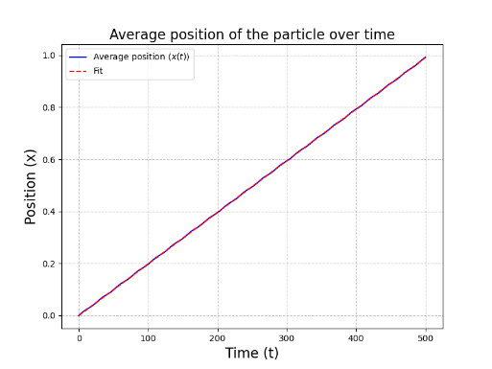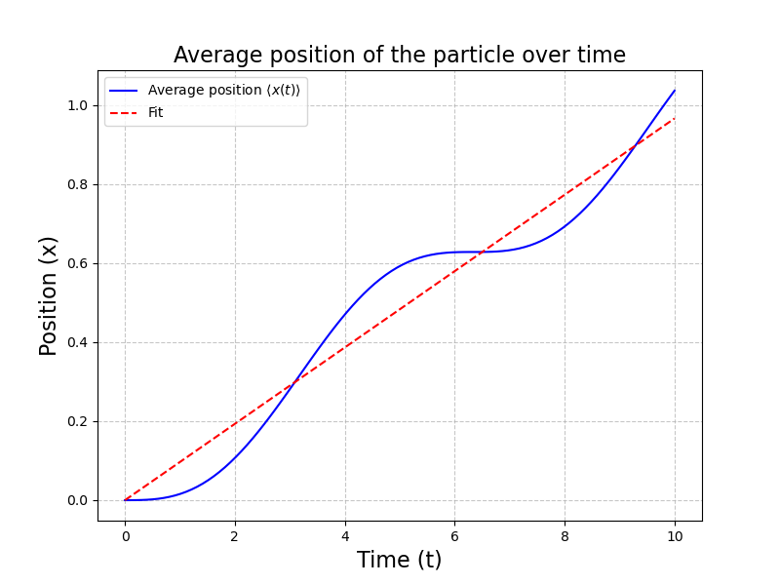

**Figure 8**: *Average position over time (real time evolution) with T = 1000*

**Figure 7**: *Average position over time (real time evolution) with T = 500*

**Figure 6**: *Average position over time (real time evolution) with T = 100*

**Figure 5**: *Average position over time (real time evolution) with T = 10*

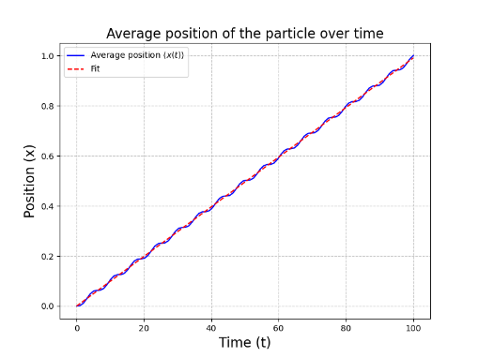

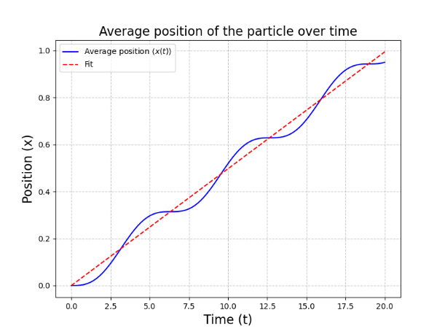

Some considerations can be done to these results. First of all, the smaller $T$ is (thus $dt$ is), the better the gifs for the time evolution look like. Also, it is possible to see from the graphs of the average position that the particle performs some oscillations as it moves to the right. These oscillations seem to increase in frequency and to be dumped as $T$ grows up. For this reason, the residuals of the average position with respect to the linear growth have been computed for different $T$, and a further Fourier analysis has been applied in order to visualize the frequency of oscillations. The results are displayed here:

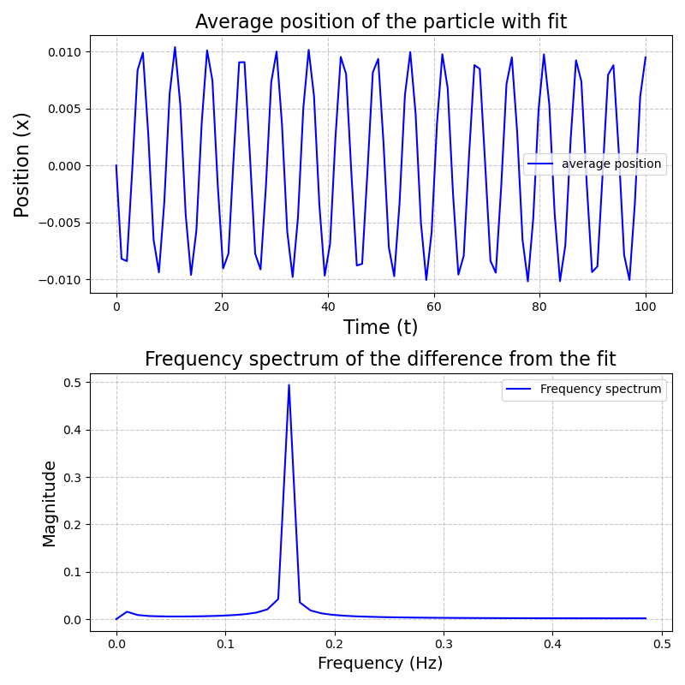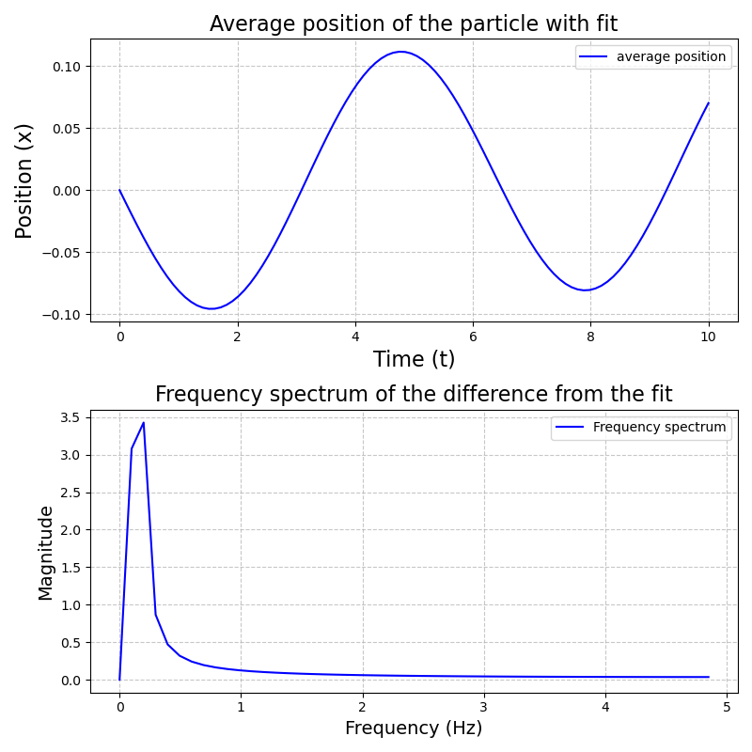

**Figure 8**: *Residual analysis of average position and frequency spectrum, with T = 10*

**Figure 9**: *Residual analysis of average position and frequency spectrum, with T = 100*

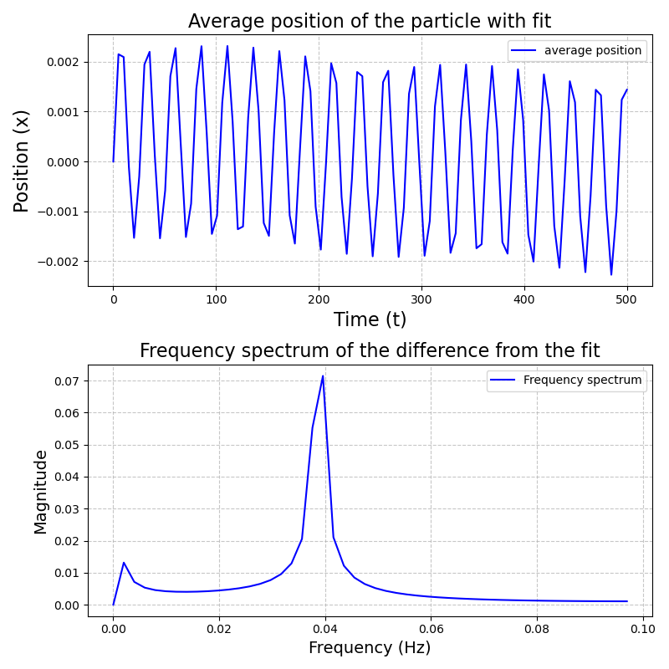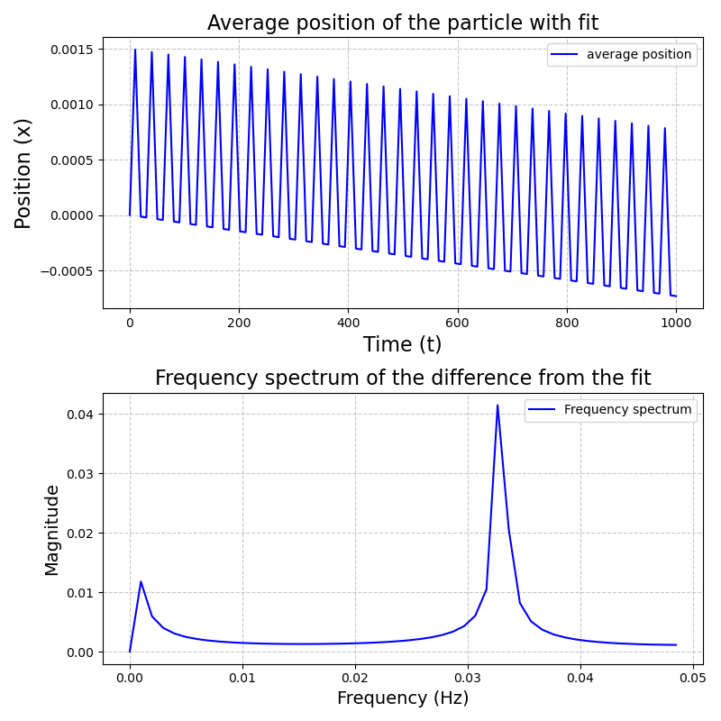

**Figure 11**: *Residual analysis of average position and frequency spectrum, with T = 1000*

**Figure 10**: *Residual analysis of average position and frequency spectrum, with T = 500*

As it is possible to see the frequency of oscillations decreases as $T$ increases, and also the amplitudes of those oscillations decrease as $T$ increases. We can make some comments on that.

From a physical point of view, first of all, starting from the fundamental state ($n = 0$), real evolution introduces nonequilibrium dynamics because of the time-dependent term ${\left(q-t/T\right)}^{2}$: the wave function evolves following the dynamics imposed by the moving minimum of the potential, and this generates oscillatory behavior. These oscillations represent the “lag” of the particle relative to the minimum of the potential, since it cannot move instantaneously with it. The particle is continuously accelerated by the gradient of the potential, but it is never exactly at the minimum.

Also, this oscillating motion emerges even if you initialize the state in the minimum, because the potential begins to shift immediately.

The inverse dependence on $T$ determines the time of change of the moving potential. When $T$ is small, the term ${\left(q-t/T\right)}^{2}$ evolves more rapidly, forcing the minimum of the potential to move with greater speed. The particle, while following the minimum, suffers from a greater dynamic delay, which amplifies the oscillations. An additional thing to consider is that varying $T$ also the energy transferred to the system changes: the higher velocity of the potential provides more energy to the system, inducing a more pronounced response of the particle. The wave function thus includes higher components in energy, which contribute to the oscillatory behavior.

Let’s now move to the imaginary time part analysis.

These are the gifs displaying the time evolution of the density of the particles varying the value of $T$.

**Figure 13**: *Imaginary time evolution with T = 1000*

**Figure 12**: *Imaginary time evolution with T = 100*

As it is possible to observe, the particle stays to the ground state, and the evolution follows as expected the center of the potential. If we now consider an excited state ($n=10$), one can see that it immediately decays to the ground state:

**Figure 14**: *Imaginary time evolution with T = 10*

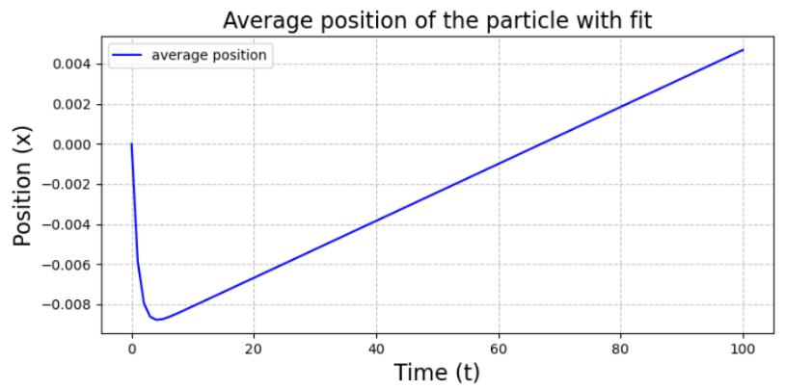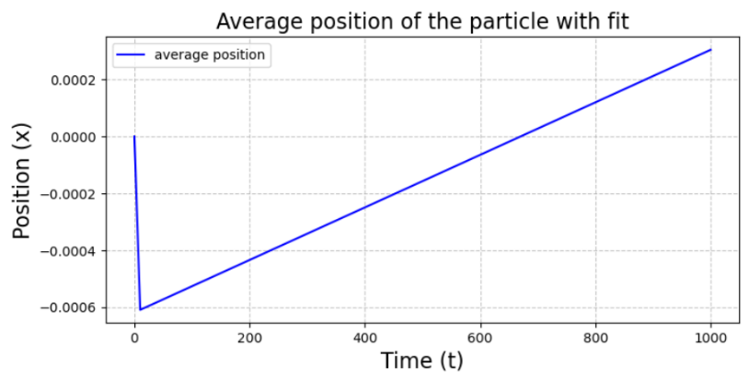The difference between the real time scenario is that the average position does not oscillate anymore. In order to better visualize this, some graphs about the time evolution of the average position have been produced, considering the wavefunction in the ground state at the initial time, which are shown here:

**Figure 16**: *Average position over time (imaginary time), with T = 1000*

**Figure 15**: *Average position over time (imaginary time), with T = 100*

Except from the first spike (due to boundary conditions) no oscillations are present during the time evolution, and some consideration can be done about it. Differently from the real time evolution, the imaginary time evolution is a technique that makes the system to converge to the fundamental state of the Hamiltonian. During this evolution, all excited components of the wave function decay exponentially, leaving only the fundamental state.

In the fundamental state, the particle is confined to the minimum energy position of the instantaneous potential, which continuously updates according to ${\left(q-t/T\right)}^{2}.$ Consequently, there is no oscillatory motion: the system is static in Hilbert space (neglecting small variations related to the numerical step).

**5. Conclusion**

The analysis revealed different behaviors under real-time and imaginary-time evolutions. For the real-time case, the particle's average position exhibits oscillations as it follows the shifting minimum of the potential. These oscillations become more frequent and amplified as $T$ decreases, reflecting the increased speed of the potential's movement and the associated energy transfer to the system. Fourier analysis of the residuals confirmed this by identifying a clear dependence of the dominant oscillation frequency on $T$, with lower $T$ corresponding to higher frequencies.

In contrast, imaginary-time evolution eliminated these oscillations entirely. Regardless of the value of $T,$ the system consistently converged to the instantaneous ground state of the Hamiltonian, as expected. This difference highlights the nature of imaginary-time evolution as a tool for finding the fundamental state, without the nonequilibrium dynamics present in real-time scenarios.

**Code**

All the data and the code for the data analysis can be found in this public Github repository:

https://github.com/sdracia/QIC.git